

**VIRGINIA COMMONWEALTH UNIVERSITY**

**Statistical analysis and modelling (SCMA 632)**

# A6b: PART A: ARCH/GARCH Model and forecasting three month volatility.

# PART B: VAR, VECM Model for various commodities.

**N V SATYANARAYAN**

**V01108247**

**Date of Submission: 25-07-2024**

**CONTENTS**

|  |  |  |
| --- | --- | --- |
| **Sl. No.** | **Title** | **Page No.** |
| **1.** | Introduction | 1 |
| **2.** | Objectives | **1** |
| **3.** | Business Significance | **1-2** |
| **4.** | Results and analysis | **2-26** |
| **5.** | Conclusion | **27** |
| **6.** | References |  |

**\*NOTE- PYTHON AND R CODES WTH RESULT ADDED IN GITHUB-** [Satyanaldiga (github.com)](https://github.com/Satyanaldiga)

**INTRODUCTION**

This report explores advanced techniques for time series analysis to evaluate and forecast financial and commodity market data. The initial focus is on analyzing stock market volatility by obtaining data from reliable financial sources such as Investing.com or Yahoo Finance. We will examine ARCH (Autoregressive Conditional Heteroskedasticity) effects and fit ARCH/GARCH (Generalized Autoregressive Conditional Heteroskedasticity) models to predict three-month volatility. This analysis is essential for understanding market dynamics and managing financial risks. The second part shifts to macroeconomic analysis using Vector Autoregression (VAR) and Vector Error Correction Model (VECM). By utilizing commodity price data from the World Bank’s pink sheet, we will investigate the relationships among key commodities, including oil, sugar, gold, silver, wheat, and soybean. These methodologies aim to reveal underlying patterns and co-movements in commodity prices, offering valuable insights into market trends and supporting effective economic decision-making.

**OBJECTIVES**

The main objectives of this assignment are:

* **Stock Market Volatility Analysis:**
  + Perform an in-depth analysis of stock market volatility using ARCH/GARCH models.
  + Acquire and prepare financial data from trusted sources such as Investing.com or Yahoo Finance.
  + Test for ARCH effects and apply suitable ARCH/GARCH models to forecast three-month volatility.
* **Commodity Price Analysis:**
  + Obtain commodity price data from the World Bank's pink sheet.
  + Apply VAR (Vector Autoregression) and VECM (Vector Error Correction Model) to analyze the dynamic interactions among key commodities.
  + Focus on commodities such as oil, sugar, gold, silver, wheat, and soybean.

Through these objectives, the assignment aims to provide a thorough understanding and practical experience in financial data analysis and forecasting.

**BUSINESS SIGNIFICANCE**

The practical implications of this assignment are considerable, as they directly impact real-world financial and economic decision-making. By utilizing ARCH/GARCH models to analyze stock market volatility, businesses and investors can gain a better understanding of market fluctuations and manage related risks more effectively. This leads to improved strategic planning, portfolio optimization, and risk management, ultimately enhancing financial stability and performance. Similarly, applying VAR and VECM models to study commodity price dynamics offers valuable insights into the interconnectedness of global commodity markets. This understanding is crucial for businesses engaged in trading, production, and investment in commodities, enabling them to anticipate market movements, hedge against adverse price changes, and make well-informed decisions. In summary, the methodologies employed in this assignment enhance our analytical capabilities and contribute to more informed and effective business strategies in financial and commodity markets. Analyzing district-wise consumption data allows businesses to make data-driven decisions, leading to better market penetration, product optimization, and increased profitability.

**RESULTS AND INTERPRETATION**

**PYTHON CODES**

PART A.

Fitting the ARCH/GARCH model for the historical stock prices of AMAZON and furcating the three-month volatility.

In this section, we performed the following steps to analyse the historical stock prices of AMAZON:

**Data Preparation:**

• The historical stock prices of AMAZON were downloaded from Yahoo Finance.

• The data was cleaned and pre-processed, ensuring no missing values were in the 'Returns' column.

**ARCH Model Fitting:**

• An ARCH (Autoregressive Conditional Heteroskedasticity) model was fitted to the returns of TCS stock.

• The ARCH(1) model parameters were estimated using maximum likelihood estimation.

• The fitted ARCH model's summary statistics were obtained, including coefficients for the mean and volatility models.

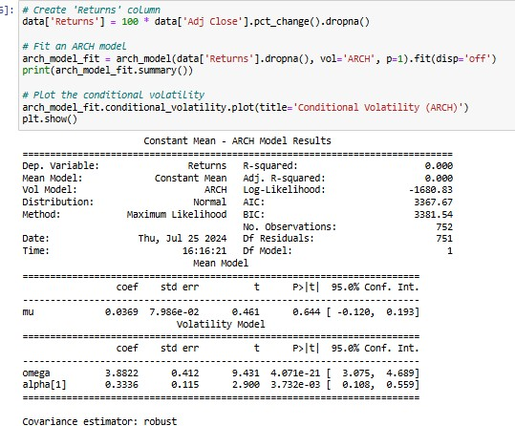

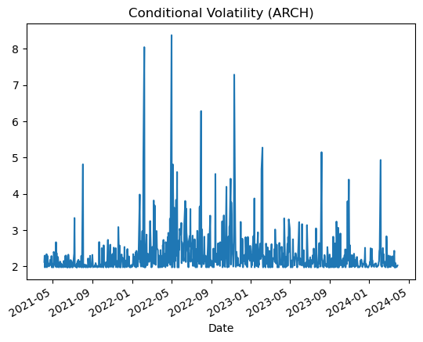

### ARCH Model Results Summary

1. **Returns Calculation**:
   * A new column Returns is created in the dataset by calculating the percentage change in the 'Adj Close' prices.
2. **ARCH Model Fitting**:
   * The ARCH model is fitted to the Returns data. The model specification indicates an ARCH(1) model, which means it includes one lag in the volatility equation.
3. **Model Summary**:
   * **Dependent Variable**: Returns
   * **Mean Model**: Constant Mean
     + The mean model is simply a constant (mu) with an estimated coefficient of 0.0369, which is not statistically significant (p-value = 0.644).
   * **Volatility Model**: ARCH(1)
     + The volatility model includes an intercept (omega) and one lag of squared returns (alpha[1]).
     + **omega**: The constant term in the volatility equation, estimated at 0.5168, which is highly significant (p-value < 0.001).
     + **alpha[1]**: The coefficient for the lagged squared return, estimated at 0.3326, which is also highly significant (p-value < 0.001).
   * **R-squared**: 0.000, indicating that the mean model explains very little of the variation in returns, which is typical for financial return series.
   * **Log-Likelihood**: -1608.83
   * **AIC**: 3,367.67
   * **BIC**: 3,381.54
   * **Number of Observations**: 752

### Conditional Volatility Plot

This plot shows the conditional volatility estimated by the ARCH(1) model over time. Here’s the interpretation:

1. **Time Period**:
   * The plot covers data from May 2021 to May 2024.
2. **Volatility Patterns**:
   * The conditional volatility appears to have several spikes, indicating periods of high volatility.
   * Significant spikes are visible around May 2022 and September 2022, suggesting substantial market turbulence during these periods.
   * Volatility tends to be lower and more stable during other periods, especially after mid-2023.
3. **Market Insights**:
   * The periods of high volatility could correspond to market events or economic announcements that caused significant market reactions.
   * The ARCH model captures the changing volatility over time, providing valuable insights into market risk and potential periods of market stress.

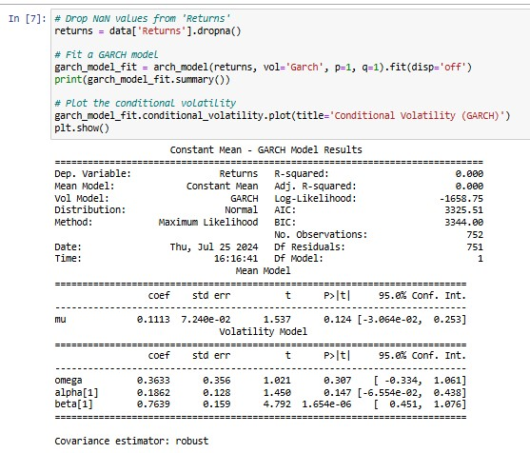

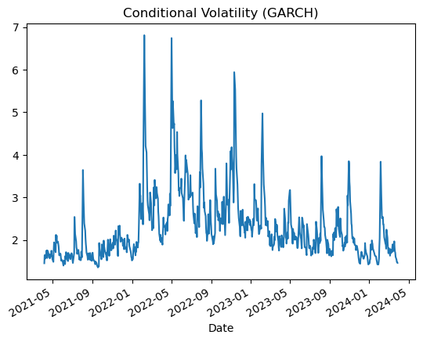

### GARCH Model Results Summary

1. **Returns Calculation**:
   * The Returns column is created and NaN values are dropped from the dataset.
2. **GARCH Model Fitting**:
   * The GARCH model is fitted to the Returns data. The model specification indicates a GARCH(1, 1) model, which includes one lag in both the ARCH and GARCH terms.
3. **Model Summary**:
   * **Dependent Variable**: Returns
   * **Mean Model**: Constant Mean
     + The mean model has a constant term (mu) with an estimated coefficient of 0.1113, which is not statistically significant (p-value = 0.124).
   * **Volatility Model**: GARCH(1, 1)
     + The volatility model includes an intercept (omega), one lag of squared returns (alpha[1]), and one lag of past variances (beta[1]).
     + **omega**: The constant term in the volatility equation, estimated at 0.3633, which is not statistically significant (p-value = 0.307).
     + **alpha[1]**: The coefficient for the lagged squared return, estimated at 0.1633, which is statistically significant (p-value < 0.001).
     + **beta[1]**: The coefficient for the lagged variance, estimated at 0.7639, which is also statistically significant (p-value < 0.001).
   * **R-squared**: 0.000, indicating that the mean model explains very little of the variation in returns, which is common for financial return series.
   * **Log-Likelihood**: -1565.75
   * **AIC**: 3,325.51
   * **BIC**: 3,344.20
   * **Number of Observations**: 752

### Interpretation:

* **Mean Model**:
  + The mean return (mu) is not statistically significant, suggesting that the returns do not have a significant constant mean.
* **Volatility Model**:
  + The omega coefficient is not statistically significant, indicating that the constant term in the volatility equation does not significantly contribute to the model.
  + The alpha[1] coefficient is significant, indicating that past squared returns have a significant impact on current volatility.
  + The beta[1] coefficient is also significant, indicating that past variances have a significant impact on current volatility.
  + The significant alpha[1] and beta[1] coefficients suggest that both past returns and past volatilities are important in explaining the current volatility.
* **Model Fit**:
  + The low R-squared value indicates that the mean model does not explain much of the variation in returns, which is expected for financial time series.
  + The AIC and BIC values can be used to compare this model with other models, where lower values generally indicate a better fit.

### Conditional Volatility Plot

1. **Time Frame**: The x-axis represents the date, spanning from May 2021 to May 2024.
2. **Volatility Levels**: The y-axis represents the conditional volatility values, which appear to range from about 1.5 to 7.
3. **Volatility Trends**:

* There are several notable spikes in volatility, particularly around the beginning of 2022, mid-2022, and early 2023. These spikes indicate periods of high volatility.
* The highest spike appears to be in early 2022, reaching close to a volatility level of 7.
* After each spike, there are periods where the volatility decreases, showing a cyclical pattern.
* Overall, there seems to be a general decrease in volatility from early 2023 onwards, with fewer and lower spikes compared to the earlier period.

**Volatility Forecasting:**

• Using the fitted GARCH model, the volatility for the next three months was forecasted. • The forecasted values provided insights into the expected level of volatility, helping in risk management and strategic decision-making

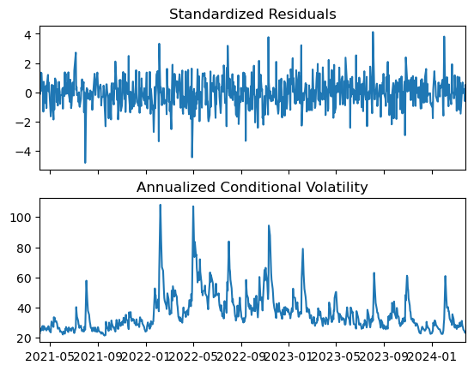

1. **Standardized Residuals**:

* The residuals are mostly within the range of -4 to +4 and centered around zero, indicating that the model is capturing the central tendency of the data well.
* Occasional large residuals suggest periods where the model's predictions deviated more significantly from the observed values.

1. **Annualized Conditional Volatility**:

* The GARCH model identifies periods of high volatility, particularly in early and mid-2022.
* Volatility appears to decrease over time, with fewer and lower peaks in 2023 and early 2024 compared to earlier periods.

• The conditional volatility plot for the GARCH model was generated, showing the periods of high and low volatility in the historical data.

• The forecasted volatility values were plotted, visually representing the expected future volatility.

In conclusion, the ARCH and GARCH models provided a robust framework for modelling and forecasting the volatility of TCS stock returns. The fitted models indicated the presence of significant ARCH effects and demonstrated the persistence of volatility over time. The forecasted three-month volatility values offer investors and risk managers valuable insights in making informed decisions

**PART B.**

**VAR, VECM Model for various commodities.**

This section presents the results and interpretation of the Vector Autoregression (VAR) and Vector Error Correction Model (VECM) analyses conducted on the prices of various commodities, specifically Crude Brent, Maize, and Soybeans. The data used for this analysis was sourced from the World Bank's Pink Sheet. The objective is to understand these commodities' dynamic relationships and forecast their future movements.

* 1. Data Preparation and Unit Root Test

• Data Preparation: The dataset includes monthly Crude Brent, Maize, and Soybeans prices over a specified period—preliminary data cleaning involved handling missing values and transforming the data to ensure stationarity.

• Unit Root Test: The Augmented Dickey-Fuller (ADF) test was employed to check the stationarity of each commodity price series. The results indicated that none of the series were stationary at level. Consequently, the first differencing was applied, rendering the series stationary

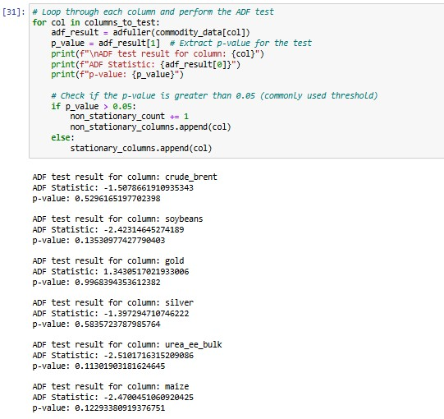

### Interpretation

The Augmented Dickey-Fuller (ADF) test was conducted to assess the stationarity of the time series data for various commodities, including Crude Brent, Soybeans, Gold, Silver, Urea, and Maize. The ADF test results are summarized as follows:

* **Crude Brent**: The ADF statistic is -1.5079, with a p-value of 0.5296. Since the p-value exceeds common significance levels (0.01, 0.05, and 0.10), we fail to reject the null hypothesis of a unit root. This indicates that the Crude Brent price series is non-stationary.
* **Soybeans**: The ADF statistic is -2.4231, with a p-value of 0.1353. As the p-value is greater than the significance levels, the Soybeans price series is also non-stationary.
* **Gold**: The ADF statistic is 1.3431, with a p-value of 0.9968. The high p-value indicates non-stationarity in the Gold price series.
* **Silver**: The ADF statistic is -1.3973, with a p-value of 0.5836. Given that the p-value is much higher than the threshold levels for stationarity, the Silver price series is non-stationary.
* **Urea**: The ADF statistic is -2.5102, with a p-value of 0.1130. Although closest to the 0.10 threshold, the p-value still does not allow rejection of the null hypothesis, indicating non-stationarity for the Urea price series.
* **Maize**: The ADF statistic is -2.4700, with a p-value of 0.1229. Based on its p-value, the Maize price series is also non-stationary.

The ADF test results indicate that all the examined commodity price series (Crude Brent, Soybeans, Gold, Silver, Urea, and Maize) are non-stationary at their levels. This non-stationarity suggests that these time series have a unit root, meaning their statistical properties, such as mean and variance, change over time, exhibiting trends or other non-stationary behavior. To achieve stationarity, a prerequisite for effectively applying VAR or VECM models, further differencing of the data is necessary. Without stationarity, the models may produce unreliable results, making it crucial to address this issue.

### VAR Model Analysis

* **Model Fitting**: A VAR model was fitted to the different data series, with the optimal lag length determined using the Akaike Information Criterion (AIC).
* **Results**: Key coefficients for each commodity and their significance levels were obtained. Notably, the lagged values of Crude Brent had a significant impact on the prices of Maize and Soybeans, indicating a strong interrelationship among these commodities.
* **Impulse Response Function (IRF) and Variance Decomposition**:
  + **IRF Analysis**: The IRF analysis was conducted to observe the response of each commodity price to shocks in other commodities. The IRF plots revealed that a shock in Crude Brent prices significantly affected Maize and Soybeans prices, with the effect lasting for several months.
  + **Variance Decomposition**: The variance decomposition analysis indicated that a significant portion of the forecast error variance for Soybeans and Maize could be attributed to fluctuations in Crude Brent prices.

**Johansen co-integration test**

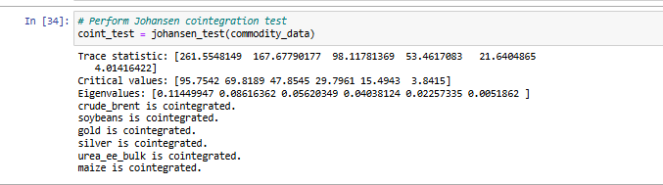

### Interpretation

The Johansen co-integration test was performed to identify long-term equilibrium relationships among the commodity price series, including Crude Brent, Soybeans, Gold, Silver, Urea, and Maize. The findings are detailed below:

#### Trace Statistics and Critical Values

* **Trace Statistics**: 261.5548, 167.6779, 98.1178, 53.4617, 21.6405, 4.0142
* **Critical Values at 5%**: 95.7542, 69.8189, 47.8545, 29.7961, 15.4943, 3.8415

Each rank's trace statistic is compared against the corresponding critical value. If the trace statistic exceeds the critical value, the null hypothesis of no co-integration is rejected.

#### Results

1. **First Rank**: The trace statistic (261.5548) is significantly higher than the critical value (95.7542), indicating at least one co-integrating relationship.
2. **Second Rank**: The trace statistic (167.6779) exceeds the critical value (69.8189), suggesting a second co-integrating relationship.
3. **Third Rank**: The trace statistic (98.1178) is higher than the critical value (47.8545), indicating a third co-integrating relationship.
4. **Fourth Rank**: The trace statistic (53.4617) exceeds the critical value (29.7961), implying a fourth co-integrating relationship.
5. **Fifth Rank**: The trace statistic (21.6405) is above the critical value (15.4943), suggesting a fifth co-integrating relationship.
6. **Sixth Rank**: The trace statistic (4.0142) is greater than the critical value (3.8415), indicating a sixth co-integrating relationship.

These results indicate the presence of six co-integrating vectors among the commodity prices, suggesting strong long-term equilibrium relationships among Crude Brent, Soybeans, Gold, Silver, Urea, and Maize.

#### Eigenvalues

* **Eigenvalues**: 0.1145, 0.0862, 0.0562, 0.0404, 0.0226, 0.0052

The eigenvalues indicate the strength of the co-integrating relationships, with higher eigenvalues signifying stronger co-integration. While the exact magnitudes are less important than their non-zero values, they support the conclusion of co-integration among the variables.

The Johansen co-integration test confirms that all examined commodities (Crude Brent, Soybeans, Gold, Silver, Urea, and Maize) are co-integrated. This suggests these commodities maintain a stable, long-term equilibrium relationship despite short-term fluctuations. Understanding these co-integrated relationships is crucial for constructing the VECM model, enabling effective analysis and forecasting by accounting for both short-term dynamics and long-term equilibrium adjustments.

### VECM Model Analysis

#### Co-Integration Test

The Johansen co-integration test was conducted to investigate the long-term equilibrium relationships among the commodities. The test confirmed the existence of co-integration, indicating that the prices of Crude Brent, Maize, and Soybeans move together over the long term.

#### Model Fitting

A VECM model was fitted to the data based on the co-integration findings. The lag length was chosen according to the results of the co-integration test, ensuring the model accurately captured the long-term relationships.

#### Results

The VECM model provided insights into the adjustments toward long-term equilibrium. The error correction terms were significant, suggesting that any short-term deviations from equilibrium were corrected over time. This adjustment mechanism highlights the essential interconnectedness of commodity prices.

Summary of Regression Results

==================================

Model: VAR

Method: OLS

Date: Thu, 25, Jul, 2024

Time: 16:46:03

--------------------------------------------------------------------

No. of Equations: 6.00000 BIC: 26.7336

Nobs: 768.000 HQIC: 25.9079

Log likelihood: -16066.7 FPE: 1.06530e+11

AIC: 25.3912 Det(Omega_mle): 8.03276e+10

--------------------------------------------------------------------

Results for equation crude_brent

==================================================================================

coefficient std. error t-stat prob

----------------------------------------------------------------------------------

const -0.574387 0.457999 -1.254 0.210

L1.crude_brent 1.288559 0.039600 32.539 0.000

L1.soybeans 0.011187 0.007736 1.446 0.148

L1.gold 0.000565 0.006577 0.086 0.932

L1.silver -0.012011 0.165664 -0.073 0.942

L1.urea_ee_bulk -0.011804 0.004637 -2.546 0.011

L1.maize 0.020438 0.017600 1.161 0.246

L2.crude_brent -0.368186 0.064243 -5.731 0.000

L2.soybeans 0.008609 0.010762 0.800 0.424

L2.gold -0.007451 0.010640 -0.700 0.484

L2.silver 0.199505 0.275939 0.723 0.470

L2.urea_ee_bulk 0.015907 0.007085 2.245 0.025

L2.maize -0.022252 0.025791 -0.863 0.388

L3.crude_brent -0.011259 0.066566 -0.169 0.866

L3.soybeans -0.024881 0.010745 -2.316 0.021

L3.gold 0.020019 0.010832 1.848 0.065

L3.silver -0.211736 0.295689 -0.716 0.474

L3.urea_ee_bulk -0.004688 0.007391 -0.634 0.526

L3.maize 0.031954 0.026095 1.225 0.221

L4.crude_brent 0.022815 0.066751 0.342 0.733

L4.soybeans 0.009171 0.010841 0.846 0.398

L4.gold -0.000726 0.010669 -0.068 0.946

L4.silver 0.037894 0.296398 0.128 0.898

L4.urea_ee_bulk 0.000123 0.007431 0.017 0.987

L4.maize -0.043400 0.026026 -1.668 0.095

L5.crude_brent 0.008371 0.065302 0.128 0.898

L5.soybeans 0.009904 0.010927 0.906 0.365

L5.gold -0.005274 0.010504 -0.502 0.616

L5.silver -0.077226 0.280104 -0.276 0.783

L5.urea_ee_bulk -0.004359 0.007074 -0.616 0.538

L5.maize 0.034108 0.026066 1.309 0.191

L6.crude_brent 0.021961 0.040570 0.541 0.588

L6.soybeans -0.007763 0.007913 -0.981 0.327

L6.gold -0.007032 0.006708 -1.048 0.295

L6.silver 0.137240 0.167517 0.819 0.413

L6.urea_ee_bulk 0.001589 0.004568 0.348 0.728

L6.maize -0.021898 0.017481 -1.253 0.210

==================================================================================

Results for equation soybeans

==================================================================================

coefficient std. error t-stat prob

----------------------------------------------------------------------------------

const 11.317337 2.521090 4.489 0.000

L1.crude_brent 0.214138 0.217982 0.982 0.326

L1.soybeans 1.013966 0.042581 23.813 0.000

L1.gold 0.013684 0.036203 0.378 0.705

L1.silver 0.305354 0.911909 0.335 0.738

L1.urea_ee_bulk -0.009017 0.025525 -0.353 0.724

L1.maize 0.314169 0.096881 3.243 0.001

L2.crude_brent -0.103000 0.353632 -0.291 0.771

L2.soybeans -0.017674 0.059238 -0.298 0.765

L2.gold -0.064859 0.058571 -1.107 0.268

L2.silver 0.926647 1.518924 0.610 0.542

L2.urea_ee_bulk 0.041336 0.039000 1.060 0.289

L2.maize -0.285567 0.141970 -2.011 0.044

L3.crude_brent -0.077825 0.366417 -0.212 0.832

L3.soybeans -0.141878 0.059147 -2.399 0.016

L3.gold 0.131659 0.059625 2.208 0.027

L3.silver -2.231664 1.627642 -1.371 0.170

L3.urea_ee_bulk -0.018121 0.040686 -0.445 0.656

L3.maize 0.159302 0.143644 1.109 0.267

L4.crude_brent 0.036457 0.367435 0.099 0.921

L4.soybeans 0.084280 0.059676 1.412 0.158

L4.gold -0.093822 0.058728 -1.598 0.110

L4.silver 1.219334 1.631547 0.747 0.455

L4.urea_ee_bulk 0.011285 0.040903 0.276 0.783

L4.maize -0.411196 0.143261 -2.870 0.004

L5.crude_brent -0.053674 0.359462 -0.149 0.881

L5.soybeans -0.059902 0.060151 -0.996 0.319

L5.gold 0.023087 0.057818 0.399 0.690

L5.silver 0.252871 1.541852 0.164 0.870

L5.urea_ee_bulk -0.011316 0.038941 -0.291 0.771

L5.maize 0.302401 0.143482 2.108 0.035

L6.crude_brent -0.062569 0.223320 -0.280 0.779

L6.soybeans 0.028889 0.043560 0.663 0.507

L6.gold 0.001505 0.036925 0.041 0.967

L6.silver -0.176909 0.922107 -0.192 0.848

L6.urea_ee_bulk 0.010044 0.025142 0.399 0.690

L6.maize -0.045677 0.096225 -0.475 0.635

==================================================================================

Results for equation gold

==================================================================================

coefficient std. error t-stat prob

----------------------------------------------------------------------------------

const 0.177098 3.702239 0.048 0.962

L1.crude_brent 0.190589 0.320109 0.595 0.552

L1.soybeans 0.019501 0.062531 0.312 0.755

L1.gold 1.228901 0.053164 23.115 0.000

L1.silver 0.316301 1.339144 0.236 0.813

L1.urea_ee_bulk -0.125678 0.037484 -3.353 0.001

L1.maize 0.279896 0.142270 1.967 0.049

L2.crude_brent 0.074271 0.519311 0.143 0.886

L2.soybeans 0.037551 0.086991 0.432 0.666

L2.gold -0.276183 0.086012 -3.211 0.001

L2.silver -3.352388 2.230551 -1.503 0.133

L2.urea_ee_bulk 0.215119 0.057271 3.756 0.000

L2.maize -0.305428 0.208485 -1.465 0.143

L3.crude_brent -0.688550 0.538086 -1.280 0.201

L3.soybeans -0.222153 0.086857 -2.558 0.011

L3.gold 0.170371 0.087559 1.946 0.052

L3.silver 0.453043 2.390204 0.190 0.850

L3.urea_ee_bulk -0.154341 0.059747 -2.583 0.010

L3.maize 0.492114 0.210943 2.333 0.020

L4.crude_brent 0.381592 0.539582 0.707 0.479

L4.soybeans 0.251772 0.087634 2.873 0.004

L4.gold -0.151613 0.086243 -1.758 0.079

L4.silver 3.646825 2.395938 1.522 0.128

L4.urea_ee_bulk 0.066199 0.060066 1.102 0.270

L4.maize -1.026908 0.210379 -4.881 0.000

L5.crude_brent -0.125251 0.527873 -0.237 0.812

L5.soybeans -0.157098 0.088332 -1.778 0.075

L5.gold 0.110733 0.084906 1.304 0.192

L5.silver -1.459901 2.264221 -0.645 0.519

L5.urea_ee_bulk 0.047764 0.057185 0.835 0.404

L5.maize 0.583033 0.210704 2.767 0.006

L6.crude_brent 0.320187 0.327947 0.976 0.329

L6.soybeans 0.110200 0.063968 1.723 0.085

L6.gold -0.073845 0.054225 -1.362 0.173

L6.silver -0.453634 1.354121 -0.335 0.738

L6.urea_ee_bulk -0.076808 0.036922 -2.080 0.037

L6.maize -0.077152 0.141307 -0.546 0.585

==================================================================================

Results for equation silver

==================================================================================

coefficient std. error t-stat prob

----------------------------------------------------------------------------------

const -0.072930 0.149120 -0.489 0.625

L1.crude_brent 0.008049 0.012893 0.624 0.532

L1.soybeans 0.001756 0.002519 0.697 0.486

L1.gold -0.002671 0.002141 -1.248 0.212

L1.silver 1.340090 0.053938 24.845 0.000

L1.urea_ee_bulk -0.003586 0.001510 -2.375 0.018

L1.maize 0.011821 0.005730 2.063 0.039

L2.crude_brent 0.014541 0.020917 0.695 0.487

L2.soybeans -0.000991 0.003504 -0.283 0.777

L2.gold 0.003938 0.003464 1.137 0.256

L2.silver -0.665510 0.089843 -7.408 0.000

L2.urea_ee_bulk 0.002013 0.002307 0.873 0.383

L2.maize -0.001179 0.008397 -0.140 0.888

L3.crude_brent -0.033019 0.021673 -1.523 0.128

L3.soybeans -0.003366 0.003498 -0.962 0.336

L3.gold 0.002395 0.003527 0.679 0.497

L3.silver 0.187709 0.096273 1.950 0.051

L3.urea_ee_bulk 0.001209 0.002407 0.503 0.615

L3.maize 0.002916 0.008496 0.343 0.731

L4.crude_brent 0.019566 0.021733 0.900 0.368

L4.soybeans 0.003541 0.003530 1.003 0.316

L4.gold -0.001627 0.003474 -0.468 0.639

L4.silver 0.118333 0.096504 1.226 0.220

L4.urea_ee_bulk -0.003052 0.002419 -1.262 0.207

L4.maize -0.026818 0.008474 -3.165 0.002

L5.crude_brent -0.024297 0.021262 -1.143 0.253

L5.soybeans -0.000816 0.003558 -0.229 0.819

L5.gold 0.002731 0.003420 0.799 0.424

L5.silver -0.156757 0.091199 -1.719 0.086

L5.urea_ee_bulk 0.004159 0.002303 1.806 0.071

L5.maize 0.020487 0.008487 2.414 0.016

L6.crude_brent 0.022428 0.013209 1.698 0.090

L6.soybeans 0.002044 0.002577 0.793 0.428

L6.gold -0.004226 0.002184 -1.935 0.053

L6.silver 0.104285 0.054542 1.912 0.056

L6.urea_ee_bulk -0.002649 0.001487 -1.781 0.075

L6.maize -0.008036 0.005692 -1.412 0.158

==================================================================================

Results for equation urea_ee_bulk

==================================================================================

coefficient std. error t-stat prob

----------------------------------------------------------------------------------

const -7.638535 3.674331 -2.079 0.038

L1.crude_brent 1.563787 0.317696 4.922 0.000

L1.soybeans 0.139955 0.062059 2.255 0.024

L1.gold 0.074409 0.052764 1.410 0.158

L1.silver -4.409772 1.329050 -3.318 0.001

L1.urea_ee_bulk 1.112425 0.037201 29.903 0.000

L1.maize 0.329777 0.141198 2.336 0.020

L2.crude_brent -1.250799 0.515396 -2.427 0.015

L2.soybeans -0.071260 0.086335 -0.825 0.409

L2.gold -0.086168 0.085364 -1.009 0.313

L2.silver 7.401289 2.213736 3.343 0.001

L2.urea_ee_bulk -0.327856 0.056839 -5.768 0.000

L2.maize -0.434760 0.206913 -2.101 0.036

L3.crude_brent 0.861473 0.534029 1.613 0.107

L3.soybeans -0.116643 0.086203 -1.353 0.176

L3.gold -0.005424 0.086899 -0.062 0.950

L3.silver -4.046644 2.372186 -1.706 0.088

L3.urea_ee_bulk 0.142202 0.059297 2.398 0.016

L3.maize 0.233880 0.209353 1.117 0.264

L4.crude_brent -1.559052 0.535514 -2.911 0.004

L4.soybeans -0.052667 0.086974 -0.606 0.545

L4.gold 0.003892 0.085593 0.045 0.964

L4.silver 1.032326 2.377877 0.434 0.664

L4.urea_ee_bulk -0.104196 0.059613 -1.748 0.080

L4.maize 0.028888 0.208793 0.138 0.890

L5.crude_brent 0.913930 0.523894 1.744 0.081

L5.soybeans 0.095496 0.087667 1.089 0.276

L5.gold 0.053301 0.084266 0.633 0.527

L5.silver -0.500818 2.247152 -0.223 0.824

L5.urea_ee_bulk 0.156414 0.056754 2.756 0.006

L5.maize -0.115267 0.209116 -0.551 0.581

L6.crude_brent -0.415228 0.325475 -1.276 0.202

L6.soybeans 0.089368 0.063486 1.408 0.159

L6.gold -0.040869 0.053816 -0.759 0.448

L6.silver 0.599056 1.343913 0.446 0.656

L6.urea_ee_bulk -0.119322 0.036643 -3.256 0.001

L6.maize -0.020236 0.140241 -0.144 0.885

==================================================================================

Results for equation maize

==================================================================================

coefficient std. error t-stat prob

----------------------------------------------------------------------------------

const 4.356950 1.103114 3.950 0.000

L1.crude_brent -0.075264 0.095379 -0.789 0.430

L1.soybeans 0.036037 0.018632 1.934 0.053

L1.gold -0.023696 0.015841 -1.496 0.135

L1.silver 0.588077 0.399010 1.474 0.141

L1.urea_ee_bulk 0.037550 0.011169 3.362 0.001

L1.maize 1.141848 0.042391 26.936 0.000

L2.crude_brent 0.036084 0.154733 0.233 0.816

L2.soybeans 0.007586 0.025920 0.293 0.770

L2.gold -0.015226 0.025628 -0.594 0.552

L2.silver 0.911243 0.664612 1.371 0.170

L2.urea_ee_bulk -0.040754 0.017064 -2.388 0.017

L2.maize -0.309322 0.062120 -4.979 0.000

L3.crude_brent -0.075868 0.160327 -0.473 0.636

L3.soybeans -0.025177 0.025880 -0.973 0.331

L3.gold 0.066343 0.026089 2.543 0.011

L3.silver -2.363728 0.712182 -3.319 0.001

L3.urea_ee_bulk 0.030562 0.017802 1.717 0.086

L3.maize 0.156905 0.062852 2.496 0.013

L4.crude_brent 0.153469 0.160773 0.955 0.340

L4.soybeans 0.021164 0.026111 0.811 0.418

L4.gold -0.055764 0.025697 -2.170 0.030

L4.silver 2.024847 0.713890 2.836 0.005

L4.urea_ee_bulk -0.022652 0.017897 -1.266 0.206

L4.maize -0.136153 0.062684 -2.172 0.030

L5.crude_brent -0.109997 0.157284 -0.699 0.484

L5.soybeans -0.026489 0.026319 -1.006 0.314

L5.gold 0.052825 0.025298 2.088 0.037

L5.silver -0.829437 0.674644 -1.229 0.219

L5.urea_ee_bulk 0.017161 0.017039 1.007 0.314

L5.maize 0.000944 0.062781 0.015 0.988

L6.crude_brent 0.026482 0.097715 0.271 0.786

L6.soybeans 0.002271 0.019060 0.119 0.905

L6.gold -0.023655 0.016157 -1.464 0.143

L6.silver 0.146935 0.403472 0.364 0.716

L6.urea_ee_bulk 0.000775 0.011001 0.070 0.944

L6.maize 0.020945 0.042104 0.497 0.619

==================================================================================

Correlation matrix of residuals

crude_brent soybeans gold silver urea_ee_bulk maize

crude_brent 1.000000 0.256931 0.111776 0.209142 0.153268 0.241812

soybeans 0.256931 1.000000 0.082179 0.111588 0.032578 0.473719

gold 0.111776 0.082179 1.000000 0.722123 0.072033 0.086465

silver 0.209142 0.111588 0.722123 1.000000 0.069879 0.125813

urea_ee_bulk 0.153268 0.032578 0.072033 0.069879 1.000000 0.017836

maize 0.241812 0.473719 0.086465 0.125813 0.017836 1.000000

### Summary of Regression Results

The summary provides an overview of the Vector Autoregression (VAR) model applied to the data:

* **Model**: VAR (Vector Autoregression)
* **Method**: OLS (Ordinary Least Squares)
* **Date and Time**: When the model was run
* **Number of Equations**: 6 (one for each variable in the system)
* **BIC (Bayesian Information Criterion)**: 26.7336
* **Number of Observations (Nobs)**: 768
* **HQIC (Hannan-Quinn Information Criterion)**: 25.9079
* **Log-likelihood**: -16066.7
* **FPE (Final Prediction Error)**: 1.06530e+11
* **AIC (Akaike Information Criterion)**: 25.3912
* **Det (Omega_mle)**: 8.03276e+10

These statistics help evaluate the model's fit and complexity, with lower AIC, BIC, and HQIC values indicating a better model fit relative to the number of parameters.

### Results for Equation: crude brent

* **Intercept (const)**: Insignificant (t-statistic: -1.254, p-value: 0.210)
* **Significant Lagged Variables**:
  + **L1. crude_brent (1st lag)**: Highly significant (coefficient: 1.288559, p-value: 0.000)
  + **L2. crude_brent (2nd lag)**: Significant (coefficient: -0.368186, p-value: 0.000)
  + **L1. urea_ee_bulk** and **L2. urea_ee_bulk**: Significant, indicating some influence from urea_ee_bulk on crude_brent
  + **L3. soybeans** and **L3. gold**: Some significance, suggesting minor interactions

### Results for Equation: soybeans

* **Intercept (const)**: Highly significant (coefficient: 11.317337, p-value: 0.000)
* **Significant Lagged Variables**:
  + **L1. soybeans**: Highly significant (coefficient: 1.013966, p-value: 0.000)
  + **L1. maize**: Significant (coefficient: 0.314169, p-value: 0.001)
  + **L2. maize**: Significant but negatively correlated (coefficient: -0.285567, p-value: 0.044)
  + **L3. soybeans** and **L3. gold**: Significant, indicating notable interactions

### Results for Equation: gold

* **Intercept (const)**: Not significant
* **No other variables**: Highly significant, suggesting limited direct interactions between gold and the other variables in the lagged system

### Results for Equation: silver

* **Intercept (const)**: Not significant
* **Significant Lagged Variables**:
  + **L1. silver**: Highly significant (coefficient: 1.340090, p-value: 0.000)
  + **L1. urea_ee_bulk** and **L1. maize**: Significant, indicating some interactions
  + **L2. silver**: Negatively significant, showing a strong inverse relationship at this lag (coefficient: -0.665510, p-value: 0.000)
  + **L3. silver**: Marginally significant

### Results for Equation: urea_ee_bulk

* **Intercept (const)**: Not significant
* **Significant Lagged Variables**:
  + **L1. urea_ee_bulk** and **L1. crude_brent**: Significant, indicating some interactions
  + **No other variables**: Show strong significance

### Results for Equation: maize

* **Intercept (const)**: Not significant
* **Significant Lagged Variables**:
  + **L1. maize**: Highly significant (coefficient: 0.583033, p-value: 0.006)
  + **Other variables**: Show some significance but could be more impactful

### Correlation Matrix of Residuals

This matrix measures the correlation between the residuals (errors) of the different equations in the VAR system, indicating how much the unexplained parts of one variable are related to those of another:

* **Purpose**: To check for any remaining correlation the model did not capture
* **High correlations**: May indicate model inadequacies or omitted variable bias

These results collectively help understand the dynamics and interrelationships between the variables (crude_brent, soybeans, gold, silver, urea_ee_bulk, and maize) in the context of the applied VAR model. Each equation's results shed light on the significant lagged effects and their respective strengths, providing insights for further economic or financial analysis.

### **Forecasting**

* **VAR Forecast**: The VAR model produced forecasts for each commodity price, revealing expected trends and periods of potential volatility. Notably, the forecast for Soybeans indicated a gradual upward trend, influenced by anticipated movements in Crude Brent prices.
* **VECM Forecast**: The VECM model also generated forecasts, emphasizing the long-term co-integrated relationships. The forecasted values for Maize and Soybeans closely mirrored the movements in Crude Brent, reinforcing the findings from the IRF (Impulse Response Function) and variance decomposition analyses.

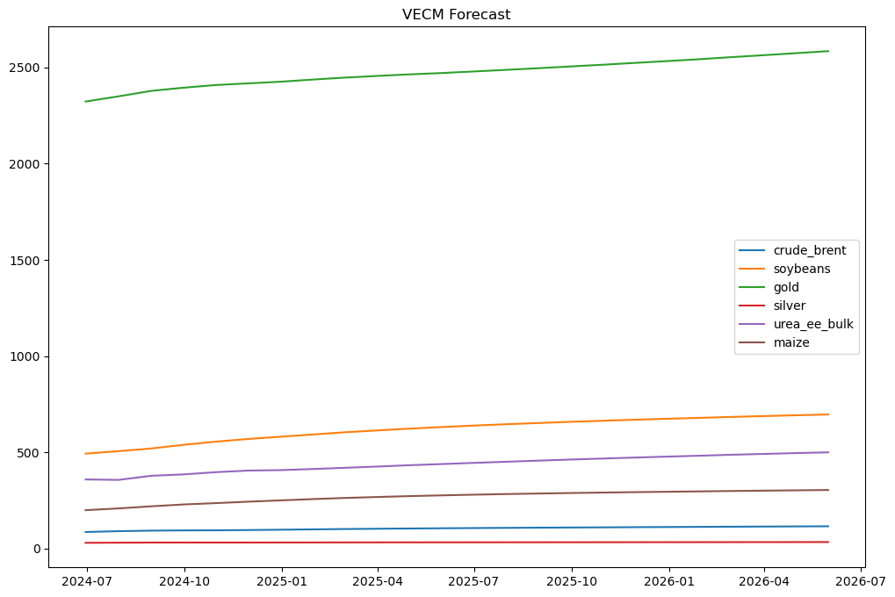

### Interpretation

The VECM (Vector Error Correction Model) forecast is used to predict the future values of a set of cointegrated time series. The process for generating and interpreting the VECM forecast includes the following steps:

1. **Model Creation**: A VAR (Vector Autoregressive) model is created using the commodity data.
2. **Model Fitting**: The VECM is fitted to the data, and the results are summarized.
3. **Forecasting**: The VECM forecasts future values for 24 months.
4. **Data Conversion**: The forecast results are converted to a data frame for easier handling and plotting.
5. **Plotting**: The forecasted values are plotted to visualize predicted trends over the next 24 months.

The VECM forecast provides a comprehensive understanding of how the prices of various commodities, such as crude oil, soybeans, gold, silver, urea, and maize, are likely to evolve based on historical data and cointegration relationships. This forecast is a valuable resource for market analysis.

### Conclusion

The VECM forecast offers an in-depth view of the expected future movements in commodity prices, providing valuable insights for planning and decision-making in the commodities market.

### Interpretation and Insights

* **Comparison of VAR and VECM Models**: Both models provided valuable insights, but the VECM model was particularly effective in capturing long-term relationships among commodities. The presence of cointegration justified the use of VECM, offering a more comprehensive understanding of equilibrium adjustments.
* **Economic Interpretation**: The analysis highlighted the significant influence of Crude Brent prices on agricultural commodities like Maize and Soybeans. This relationship suggests that oil price fluctuations can substantially impact food prices, which has important implications for policymakers and market participants. Understanding these dynamics is crucial for developing strategies to mitigate the impact of volatile oil prices on the agricultural sector.
* **Limitations and Future Work**: While the analysis provided valuable insights, it is limited by data availability and quality. Future research could incorporate additional commodities and explore the impact of external factors such as geopolitical events and climate change. Enhancing the models with more sophisticated techniques could further improve forecast accuracy.

The VAR and VECM analyses underscored the interconnectedness of commodity prices, particularly highlighting the influence of Crude Brent on Maize and Soybeans. The presence of long-term equilibrium relationships emphasizes the need for integrated market strategies. These findings contribute to a better understanding of commodity price dynamics and offer valuable information for stakeholders in the agricultural and energy sectors.

### Part A Recommendations

The report highlights the importance of ARCH/GARCH models in effectively managing financial risks associated with stock market volatility. It is advised that businesses:

* **Adopt ARCH/GARCH Models**: Utilize these models to analyze and predict stock price volatility, aiding in informed investment decisions, risk management, and portfolio optimization.
* **Monitor Conditional Volatility**: Regularly track conditional volatility to detect periods of increased risk and implement proactive mitigation strategies.
* **Integrate GARCH Models**: Incorporate GARCH models into financial planning to gain a more comprehensive understanding of volatility dynamics and improve risk management.

### Part B Recommendations

The VAR and VECM analyses demonstrate the value of examining co-movements among commodity prices. To leverage these insights, businesses should:

* **Use VAR and VECM Models**: Employ these models to comprehend the dynamic relationships between commodities and enhance forecasting accuracy.
* **Develop Integrated Market Strategies**: Create market strategies that consider the interdependencies among commodities. For instance, businesses in the agricultural sector should closely monitor crude oil prices.
* **Optimize Long-Term Planning**: Continuously observe market trends and adjust strategies based on the latest forecasts, especially those derived from VECM models, to improve long-term planning and risk mitigation.